Prehistoric People
Like people today, prehistoric people lived in social groups. They lived in a network of relationships with other human beings, including family members, neighbours or nearby groups. Such a network of people who interact with one another is called a _____________.
People who live and work together share many habits, ideas, skills, traditions and values. All of these habitual ways of thinking and acting make up a societies ____________. Culture is a way of life that a group of people develops and passes on to its children.
________________ are scientists who discover and study the remains of ancient societies. ___________________ are scientists who study the ways societies and cultures are organized.
From the ______________ and _____________ left behind by prehistoric peoples, anthropologists know a great deal about how they got their food and made their tools. However, anthropologists know very little about prehistoric people`s thoughts and feelings, religious beliefs or their ideas of right and wrong.
Old Stone Age (2 000 000 years ago)
Also called the ________________ Age or Ice Age
Early humans used ______________ for their tools and weapons. These greatly improved over a long period of time and were eventually also made of ________________, ________________ and ________________.
People lived by __________________ animals and __________________wild foods, such as nuts and berries.
They moved often in search of food which made them __________________.
The invention of ________________ helped in the cold climates, provided light, and protection from dangerous animals.
Some form of _________________ development took place.
Lived in groups of 25 – 40 individuals. Were a society of ____________________, there were no kings or chiefs.
The beliefs of these people remains a mystery, although there are clues that they buried their dead which means they may have believed in an afterlife.
Scientists believe that human life began in the Rift Valley in eastern ___________________.
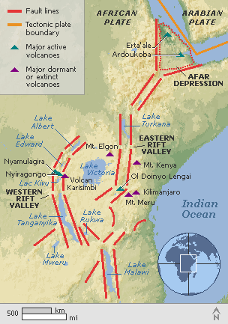
New Stoneage (10 000 years ago)
Also called the ___________________ Age
People learned to _______________, herd, and began to live in ___________________ settlements
_________________ may have been the first farmers, since they were the ones who gathered the plants and sowed the seeds
Some animals were _______________________ or tamed for human use
Ex. Northern Europe – dogs
South West Asia – sheeps, goats, pigs and cattle
Many hunters roamed the Sahara Desert for elephants, giraffes and gazelles
By 3000 BC, climate changes were turning the Sahara into a vast desert, so the people moved to other regions
Early permanent settlements grew up by ________________, ________________ or _________________
______________________ was developed from clay to prevent crops that were harvested from dampness and insects
Tool makers begin to _____________ and _________________ stone instead of chipping it
Settlements allowed for ___________________ increase of the worlds` populations

 | Paleolithic | Neolithic
Housing

Means of Living

Technology

Social Organization

