Map of Ancient Mesopotamia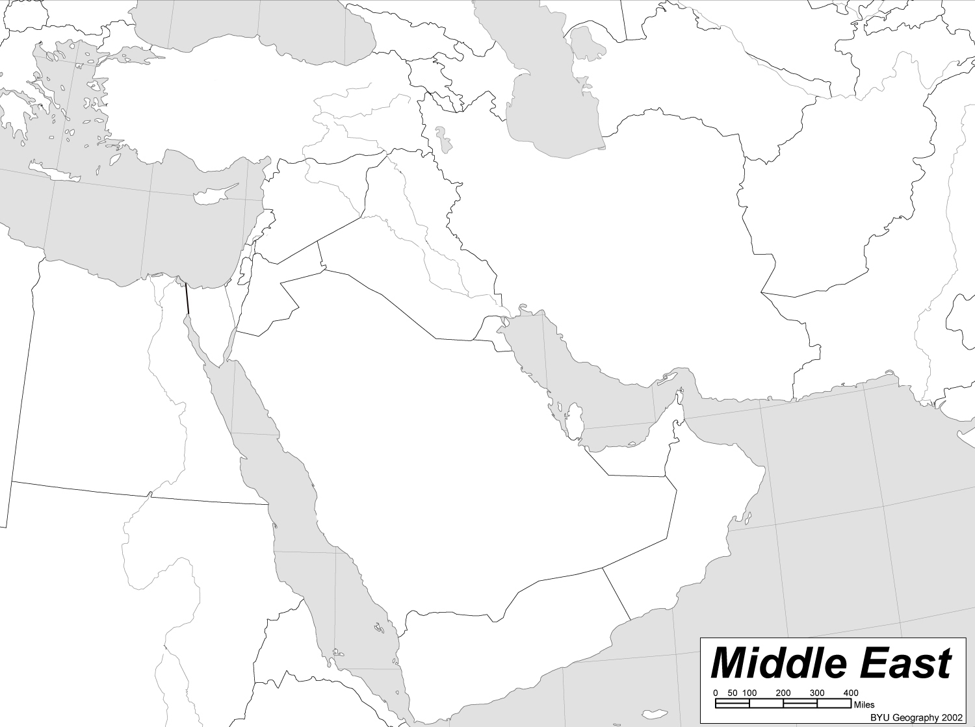
- Label the modern countries on the map
- Label the following rivers and outline them in blue: Euphrates, Tigris, Nile
- Draw the location of the following mountain ranges using a ^: Taurus Mountains, Caucasus Mountains, Zagros Mountains
- Label the Mediterranean Sea, the Red Sea, the Persian Gulf, the Black Sea, and the Caspian Sea
- Label the Syrian Desert
- Label the Sinai Peninsula
- Colour and label the Dead Sea and the River Jordan
- Shade in the area of the fertile crescent using green pencil crayon
- Use different colours to shade in the areas occupied by the following civilizations: Sumeria, Babylonia, Arabia, Persia, Upper and Lower Egypt, Phoenicia, Assyria, Anatolia
- Label the cities of: Babylon, Eridu, Uruk, and Ur
- Label Gobekli Tepe
1792 to 1750 BCE – reign of Hammurabi of the First Babylonian Dynasty, extended control throughout Mesopotamia, known for the Code of Hammurabi, one of the earliest codes of law
1500 to 539 BCE – Phoenicia and the spread of their alphabet from which almost all modern phonetic alphabets derived
1300 BCE – discovery of iron smelting and smithing techniques in Anatolia or the Caucasus: start of the Iron Age

3600 BCE – first civilization in the world: Sumer (city-states) in modern-day southern Iraq
3500 to 3000 BCE – one of the first appearances of wheeled vehicles in Mesopotamia
3500 BCE – first cities in Egypt
3300 BCE – earliest hieroglyphs
3200 BCE – Iry-Hor reigns as pharaoh of Upper Egypt, the earliest historical person known by name
3000 BCE – first examples of Sumerian writing in Mesopotamia, in the cities f Uruk and Susa (cuneiform writings)

4000 BCE – first use of light wooden ploughs
4000 BCE – Egyptians discover how to make bread using yeast
4000 BCE – city of Ur in Mesopotamia

6000 BCE first irrigation and flood control in Mesopotamia and Egypt
6000 to 4300 BCE – first sail boats in Mesopotamia

7 000 BCE – first fired pottery

5600 BCE – Black Sea floods according to the Black Sea deluge theory
5509 BCE – date of creation according to the Byzantine calendar
5500 BCE – first large scale agriculture by the Sumerians and in the valley of the Nile
5403 BCE – expulsion from the Garden of Eden according to the Genealogies of Genesis
2900 to 2350 BCE – first ziggurats in Sumer
2560 BCE – completion of the Great Pyramid of Giza
2500 BCE – first domestication of the camel in central Asia

8 000 BCE – first domestication of goats
8 000 BCE – first domestication of wheat

0
2 000 BCE
4 000 BCE
6 000 BCE
8 000 BCE
2 000 CE
1 000 CE
1 000 BCE
3 000 BCE
5 000 BCE
7 000 BCE
9 000 BCE
10 000 BCE
9 000 – 7 000 BCE – first domestication of sheep in Mesopotamia
8 500 BCE – first domestication of the cow in Turkey and Northern Iraq

10 000 BCE 0 Gobekli Tepe established
9300 BCE – first cultivating of wild crops in areas of Jordan

