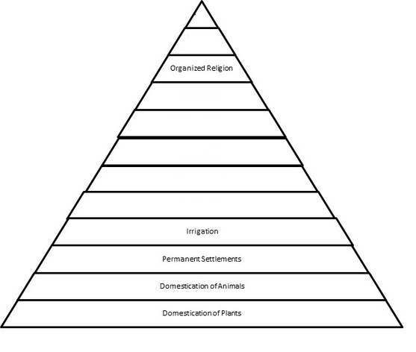
Fill in the missing steps on the pyramid, and explain how each one would have affected the society.
- _________________

- _________________

- _________________

- _________________

- _________________

- _________________

- _________________

The Impact of the Fall of the Roman Empire
Introduction of Christianity
Decline in Morals and Values
Public Health
Political Corruption
Unemployment
Inflation
Urban Decay
Inferior Technology
Military Spending
Influx of Foreign Invaders
Categorize each of the reasons listed above into one of categories below. Then give a modern day, Canadian topic that would fit into each category and explain how it is affecting our society.
Religion | Economics | Politics | Social Factors | Technology

